**FAST2SMS**

IoT Based Safety Gadget for Child Safety Monitoring and Notification

**CREATE A FAST TO SMS SERVICE:**

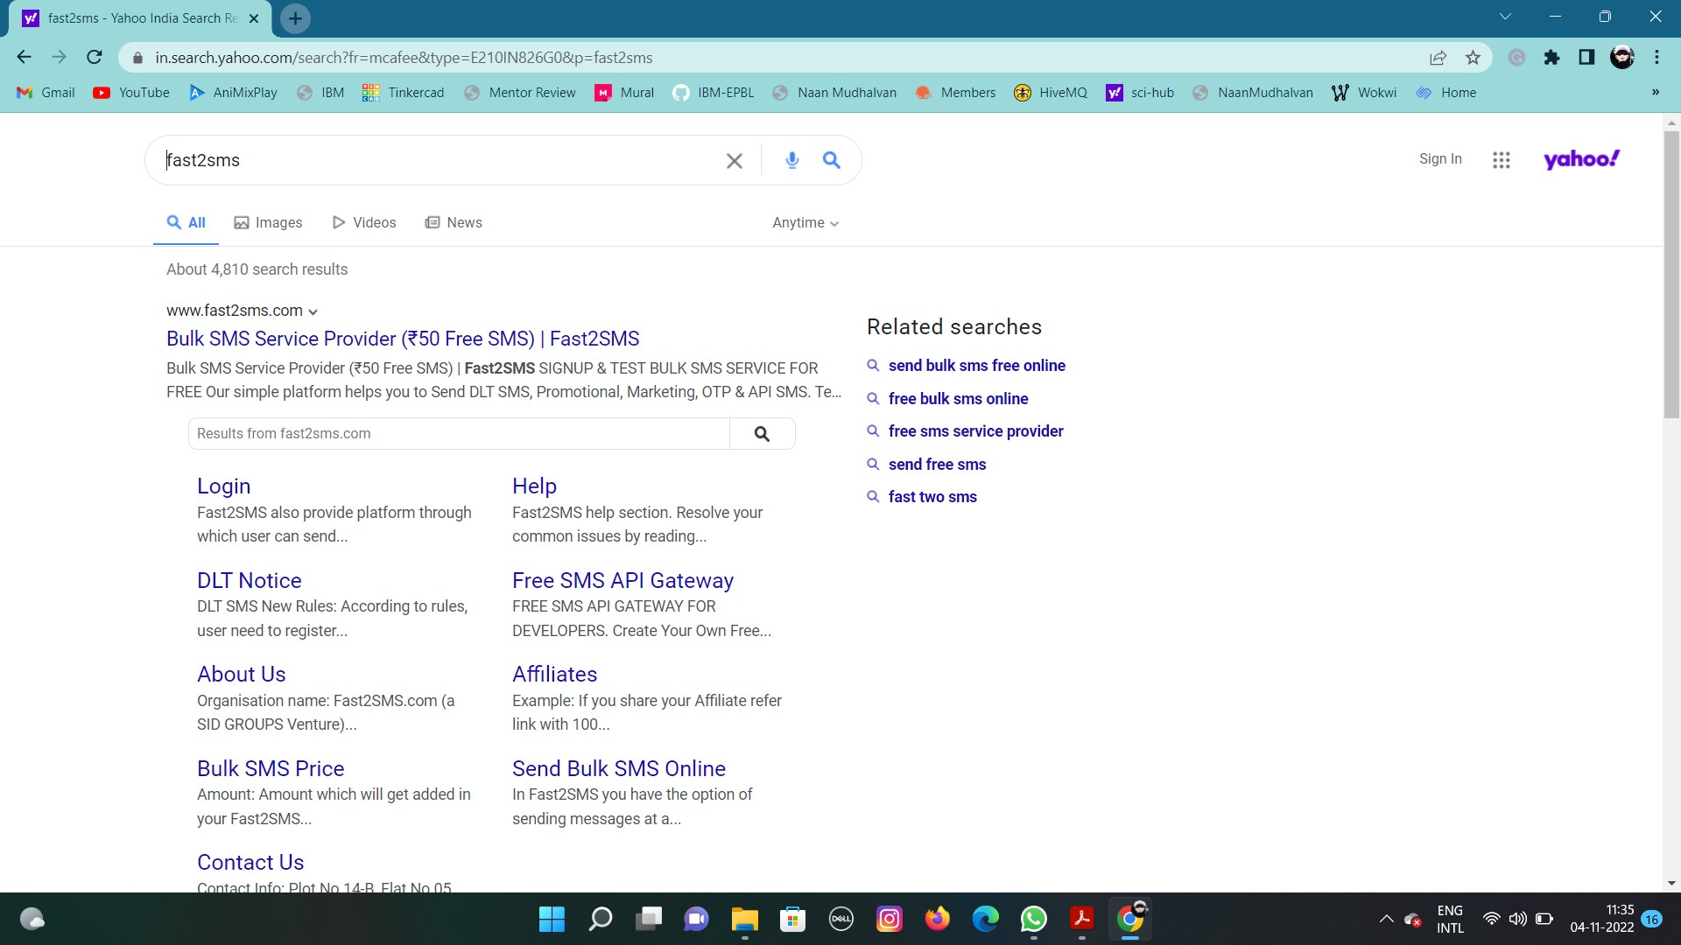**STEP 1:** Type fast2sms in google.

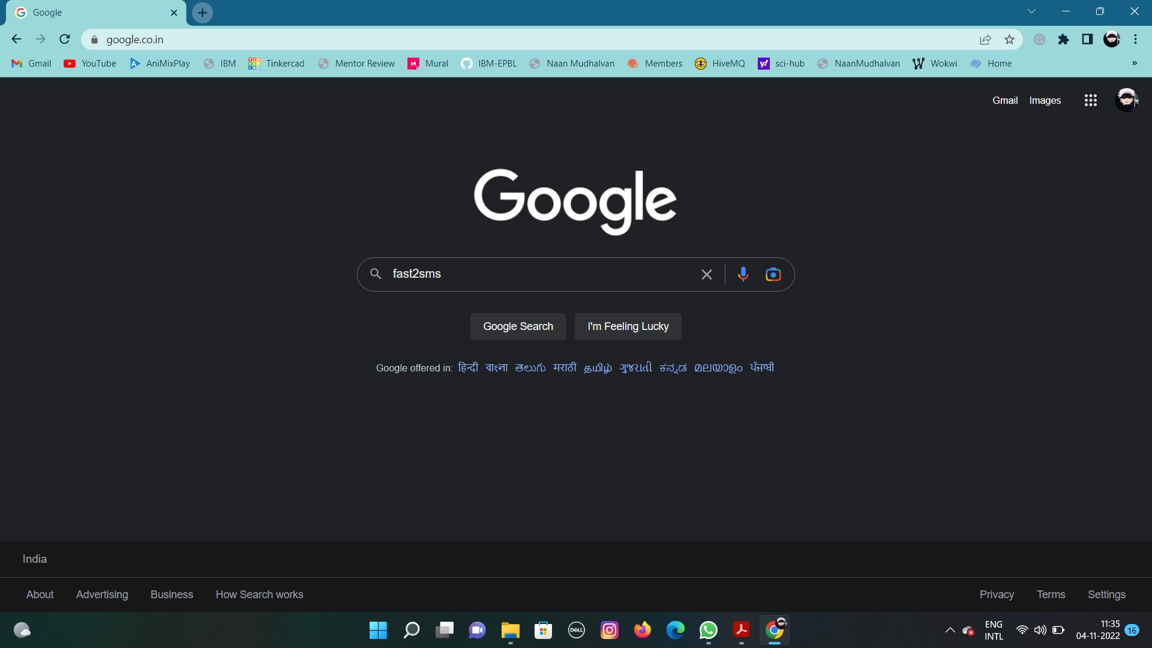

**STEP 2:** Click on the first link

**STEP 3:** Click on SIGNUP NOW.

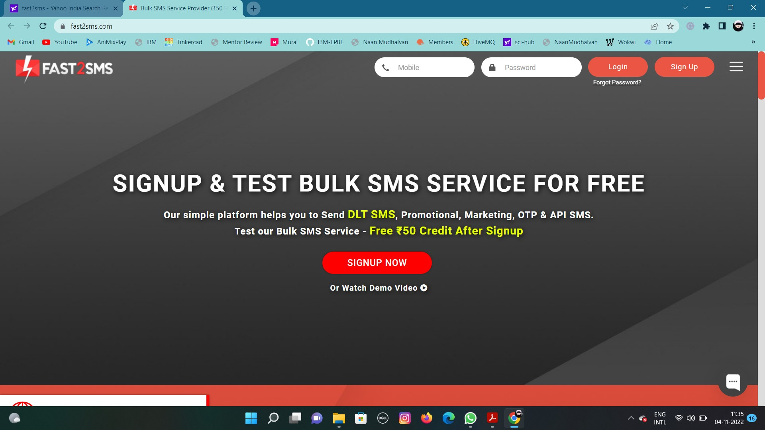

**STEP 4:** Give your details and click on the check box then click the submit button.

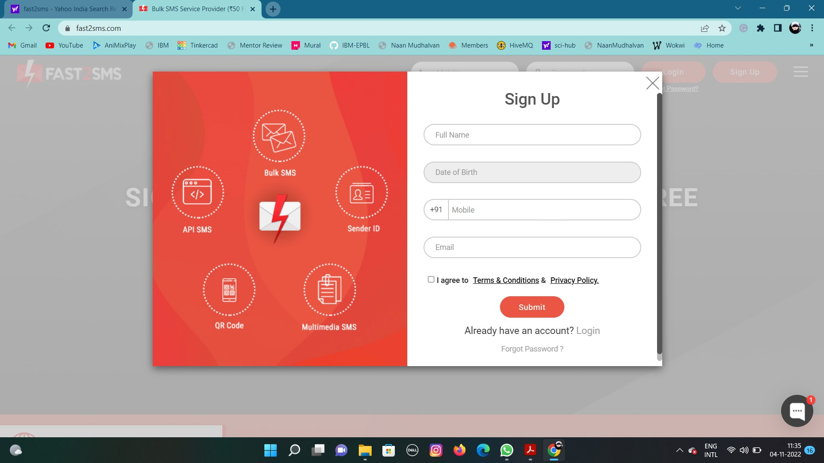

**STEP 5:** You will get the SMS with your password. Type your mobile number and the password then click on the submit button.

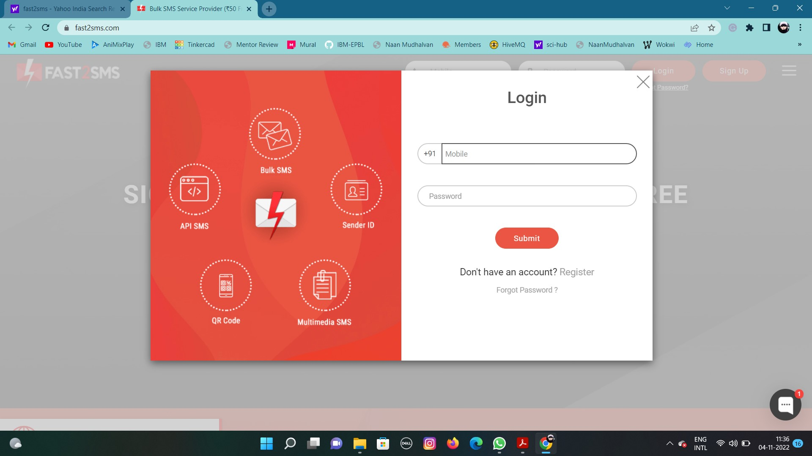

**STEP 6:** Type your email address and click on the VERIFY NOW button.

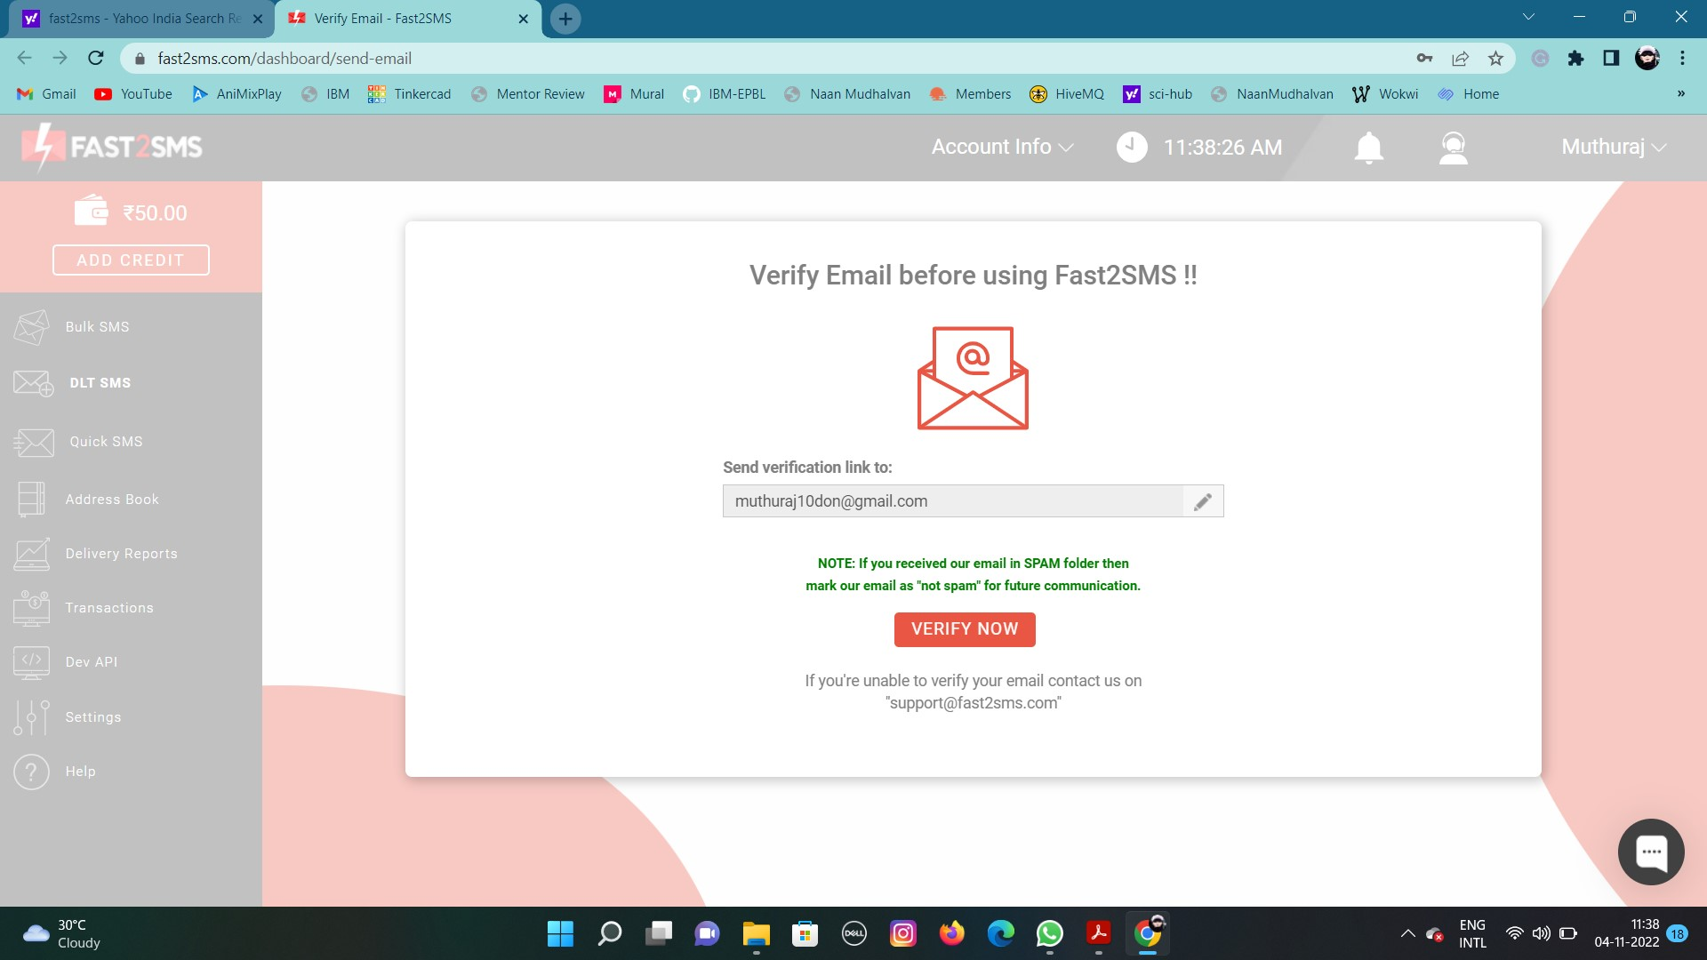

**STEP 7:** Click on the Dev API.

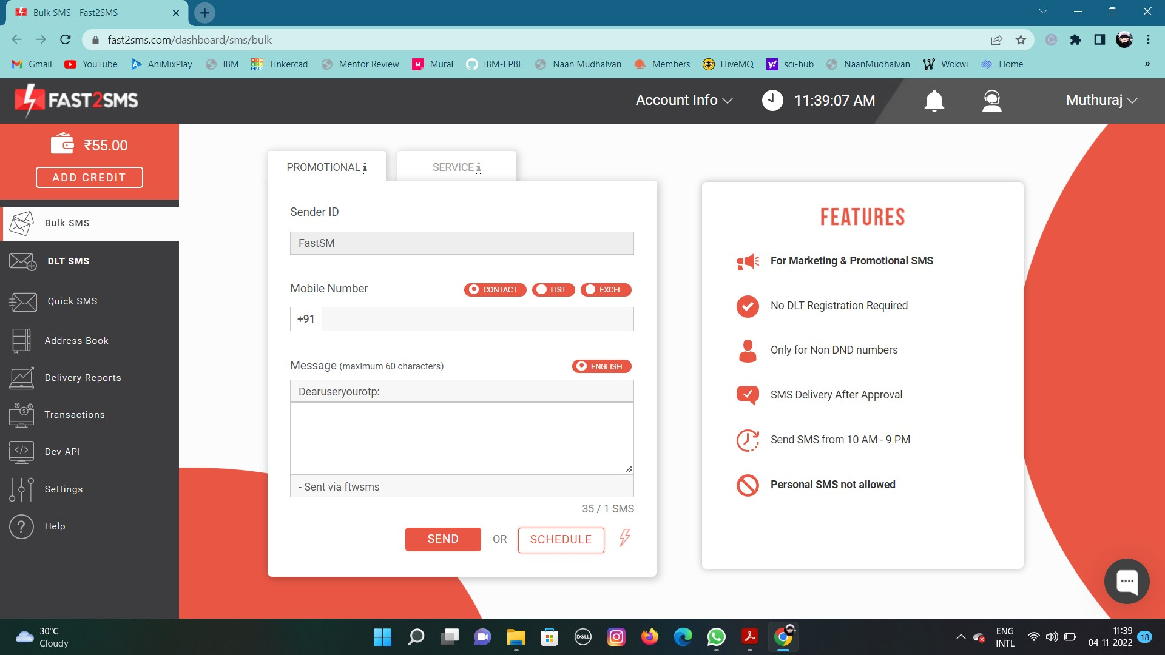

**STEP 8:** Select the Route as Quick SMS and type the message in the Message box.

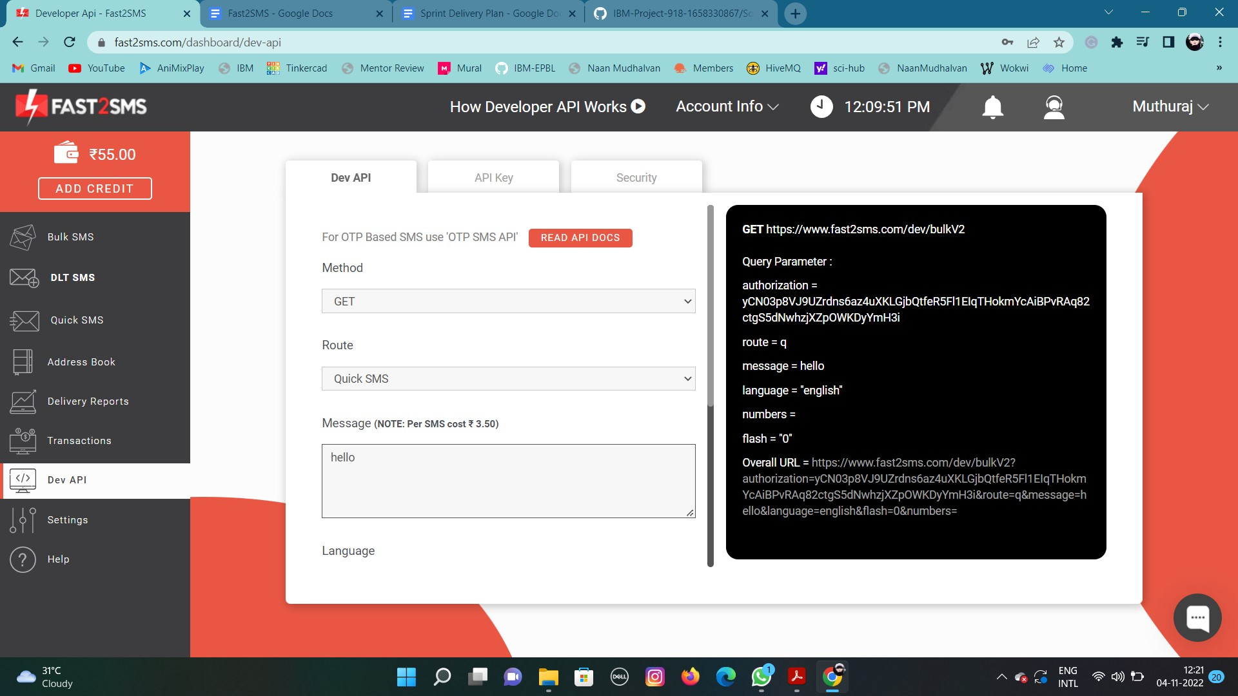

**STEP 9:** Select your language and type your mobile number in Contact.

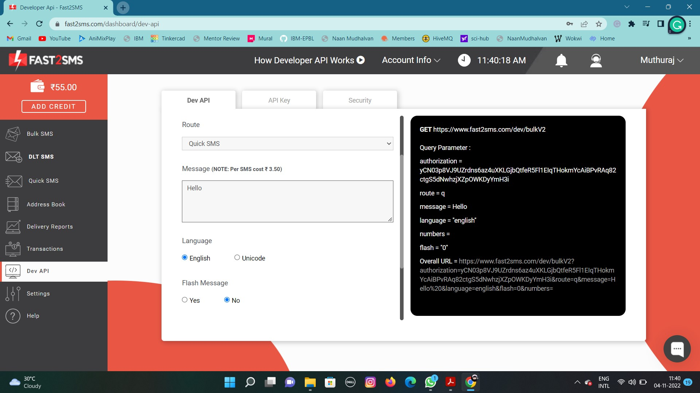

**STEP 10:** Copy the URL and paste it into the new tab.

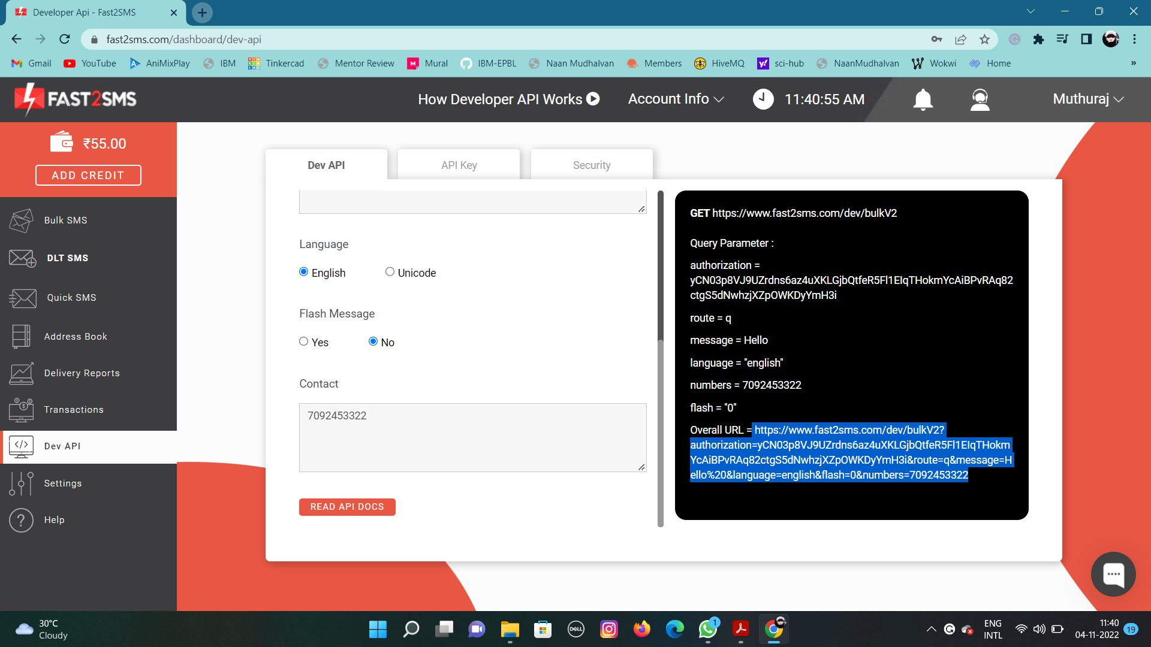

**STEP 11:** You will get the SMS in the new tab.

